NOVAC Technology Solutions



Business Requirement Document

For

SGI Philippines – Changes in Proposal Entry for CTPL Policies in ZIVA Application

Revision History

Version No. | Date | Reason For Changes | Author | Reviewer | Approver
Draft 163.1 | 24-March-2025 | Draft document to mandate the MV File number for CTPL Policies | PL.Nijanthan | M. Arunkumar | Mr. Manoj Joseph
163.0 | 27-March-2025 | Baseline document of draft version | PL.Nijanthan | M. Arunkumar | Mr. Manoj Joseph

Table of Contents
1. Introduction 4
1.1. Purpose 4
1.2. Project scope 4
1.3. References 4
1.4. System Description 4
2. Functional Overview 4
2.1. Changes in CTPL Policies 4
2.2. Changes in the Policy Schedule 5
2.3. Assumption and Dependencies 5
3. Interface Requirements 5
3.1. Internal Interfaces 5
3.1.1. Hardware Interface 5
3.1.2. Software Interface 5
3.1.3. Communication Interface 5
3.2. External Interfaces 6
3.2.1. Hardware Interface 6
3.2.2. Software Interface 6
3.2.3. Communication Interface 6
3.3. Operating Environment Requirement 6
3.3.1. Hardware Requirements 6
3.3.2. Software Requirements 6
3.3.3. Network Requirements 6
3.3.4. Operational scenarios 6
3.4. Non Functional Requirements (NFR) 6
3.4.1. Reliability 6
3.4.2. Performance 6
3.4.3. Security 6
3.4.4. Usability 6
3.4.5. Other Requirements 7
3.5. Open Issues 7
3.6. Acceptance Criteria 7
4. Appendix A 7

Introduction

Purpose
The purpose of this requirement, to mandate the MV File number for the CTPL policies in the ZIVA application.
  - Guidelines, circulars, instructions and directions released from time to time by Philippines Insurance council.

Project scope
To mandate the MV File number for the CTPL policies in the both the RFQ and Proposal entry screen

References

System Description
The system to mandate the MV File number for the CTPL Policies in the both RQF and Proposal entry screen.

Functional Overview

The system should mandate the MV File number for the CTPL policies in both the RFQ and Proposal entry screen.

Changes in CTPL Policies
In the Current system, the MV File No is the non-mandatory field for the CTPL Policies.
Now the system is required to mandate the MV File No for the CTPL policies in both RQF and Proposal entry screen. This is applicable for both Individual Motor Policies and Motor Fleet Policies.
The system should mandate the MV File Number during the endorsement, if the policy does not have the MV file number. This requirement is not applicable to all endorsement cases, this is only applicable when an endorsement is initiated and navigates to the full-screen similar to the Proposal Entry screen and the system should mandate the MV File Number field for those specific endorsements during the endorsement process.
For the Motor Fleet policies, System should validate and mandate the MV File number during the process of child policies / Vehicle details upload. If the MV File Number is missing in the uploaded Excel file, the system should display an error message as “MV File Number is mandatory for CTPL policies”, similar to existing validation messages. System should mandate the MV File number during the upload of new child policies (Inclusion of Vehicle).

Changes in the Policy Schedule
The system should display the MV File No in the Policy schedule next to the Color field. Refer the below screen shot for reference.
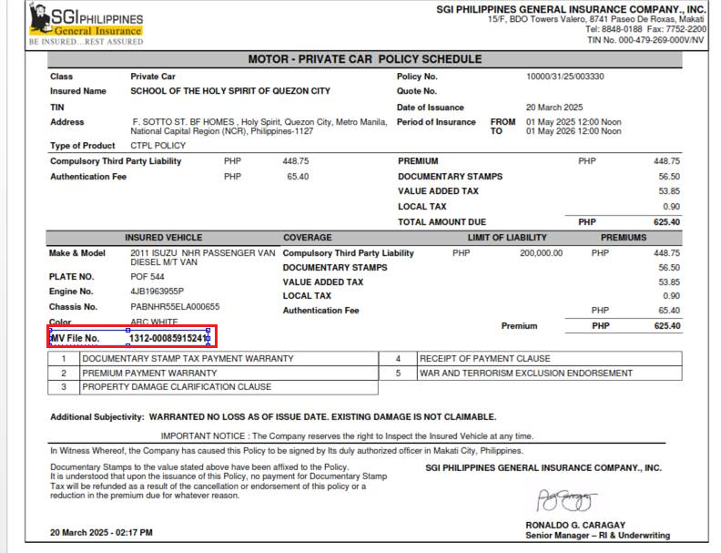

Assumption and Dependencies
<Not Applicable>

Interface Requirements

Internal Interfaces

Hardware Interface
<Not Applicable>

Software Interface
<Not Applicable>

Communication Interface
<Not Applicable>

External Interfaces

Hardware Interface
<Not Applicable>

Software Interface
<Not Applicable>

Communication Interface
<Not Applicable>

Operating Environment Requirement
<Not Applicable>

Hardware Requirements
<Not Applicable>

Software Requirements
<Not Applicable>

Network Requirements
<Not Applicable>

Operational scenarios
<Not Applicable>

Non Functional Requirements (NFR)

Reliability
<Not Applicable>

Performance
<Not Applicable>

Security
<Not Applicable>

Usability
<Not Applicable>

Other Requirements
<Not Applicable>

Open Issues
<Not Applicable>

Acceptance Criteria
- Functional testing will be executed by internal testing team, and the same will be delivered to client for UAT.

Appendix A
Not Applicable

